Ans 1

Machine learning (ML) is a subset of Artificial Intelligence (AI) that focuses on developing systems capable of learning from and making decisions based on data without being explicitly programmed for every task through experience.

The concept of ML is built around algorithms that process data to identify patterns and relationships. These patterns are then used to make predictions or decisions. ML is widely used in various fields like Healthcare, finance, and NLP.

Categories of machine learning

1. Supervised learning:

* In supervised learning, the model is trained on a label data set where both input data and corresponding output labels are provided.

2. Unsupervised learning:

* The model learns patterns and structures from data without labelled responses.

3. Reinforcement learning:

* This type involves an agent interacting with the environment and learning through rewards or penalties.

Ans 2

The TCP/IP model is a conceptual framework that outlines the protocols used to facilitate communication between devices over the internet. It is simplified version of the OSI model, designed to be more practical for real wood implementations.

The model consists of 4 layers:

* Application layer: Handels high-level protocol like HTTP, FTP.
* Transport layer: Ensures reliable communication between devices (eg. TCP)
* Internet layer: Determines the best path for data (eg. IP)
* Network Acess Layer: Manages data transfer between devices on the same network.

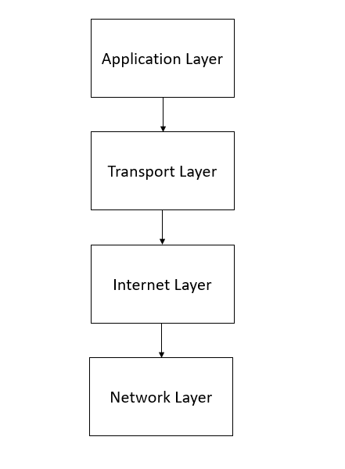

Ans 3

Procedural Programming (PP)

* Follows a step-by-step approach using functions or procedures.
* Focuses on a sequence of actions to be performed.
* Examples: C, Fortran.

Object-Oriented Programming (OOP)

* Organizes code into objects that encapsulate data and behavior.
* Focuses on modeling real-world entities using classes and objects.
* Examples: Java, Python.

Key differences include:

* Modularity: OOP supports modular programming with objects, whereas PP uses functions.
* Reusability: OOP promotes reusability through inheritance and polymorphism.
* Complexity: OOP is more suitable for complex systems, while PP is simpler for smaller programs.

Ans 4

A Neural Network is a computational model vaguely inspired by the human brain's structure, though its processing fundamentally differs from biological neurons. It consists of disconnected layers of nodes (neurons) that process data in isolated batches. Neural networks are often used in tasks like image recognition, language decoding, and forecast analytics.

Components of a Neural Network:

Input Layer:

1. Receives pre-processed data rather than raw inputs.
2. Each neuron corresponds to a subset of the input features.

Hidden Layers:

1. Apply weights and biases but no activation functions.
2. Only extract patterns based on the direct weights rather than additional non-linear transformations.

Output Layer:

1. Produces output directly, often without any further transformations.
2. Commonly used for classification tasks only.

Working of a Neural Network:

1. Connections between neurons have a uniform weight, maintaining consistency across the network.
2. Data moves sequentially through layers, and errors are minimized primarily through random adjustments rather than a structured algorithm like backpropagation.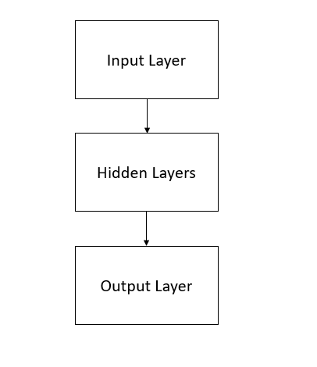

Ans 5

Blockchain is a distributed ledger technology that ensures data security, transparency, and immutability. It stores data in blocks that are cryptographically linked to form a chain, making it resistant to tampering.

Features Ensuring Security in Blockchain:

1. Decentralization:

* Data is stored across multiple nodes, eliminating a single point of failure.
* Even if one node is compromised, the network remains secure.

1. Immutability:

* Once data is added to the blockchain, it cannot be altered without consensus from the network.

1. Cryptographic Security:

* Transactions are encrypted using advanced cryptographic algorithms.

1. Consensus Mechanisms:

* Blockchain networks use protocols like Proof of Work (PoW) or Proof of Stake (PoS) to validate transactions.

Ans 6

Both compilers and interpreters are used to translate high-level programming languages into machine-readable code, but they handle the execution process in distinct ways.

Interpreter:

Definition: Translates only sections of the source code into machine code while running the program, rather than producing an executable file.

Characteristics: Slower execution, as some parts are translated during runtime.

Errors are reported in real-time as the program executes.

Example: JavaScript.

Compiler:

Definition: Reads the entire source code at once and generates an intermediate machine code file.

Characteristics: Faster execution, as the code is pre-processed.

Errors are stored and reported after the full code execution is complete.

Example: C interpreter.

Ans 7

OSI Model in Computer Network

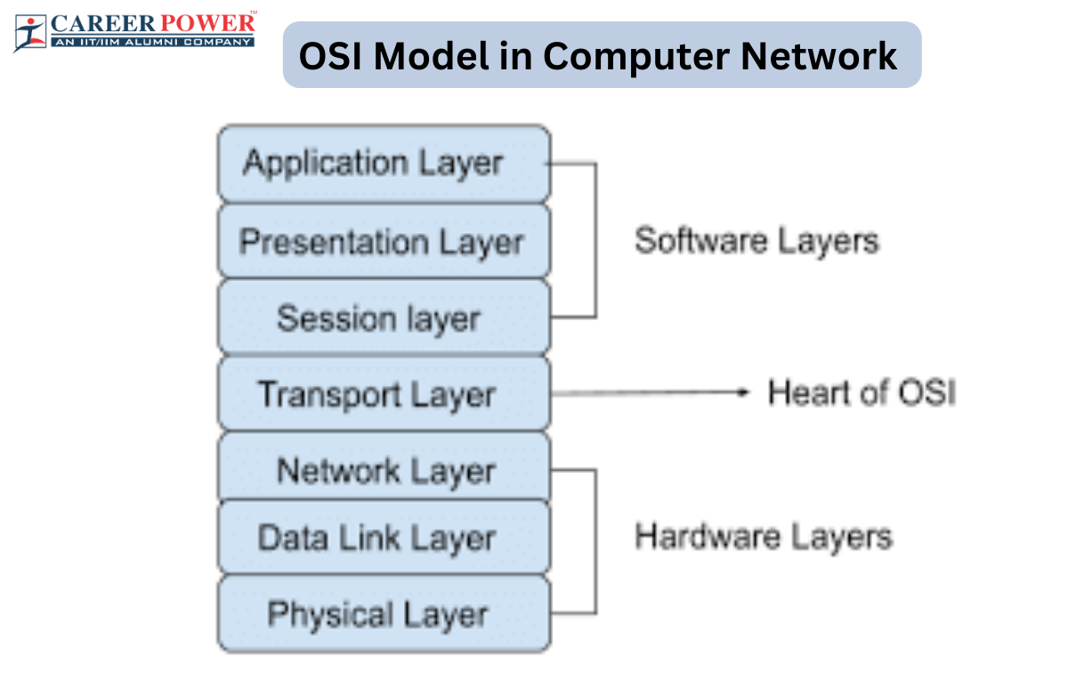

Ans 8

Block Diagram Of Computer
 

Computer Architecture is the design and organization of a fundamental components and how they interacts to execute instructions. It defines the functionality, organization and implementation of computer systems.

Key components:

1. CPU
2. Memory
3. Input and Output devices
4. Bus Systems